[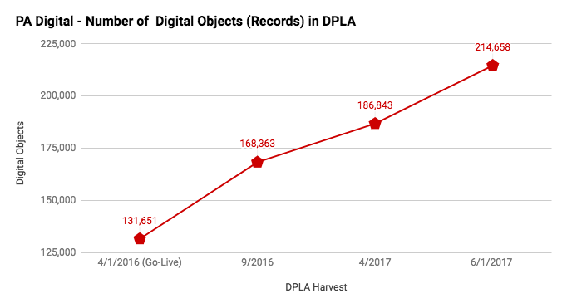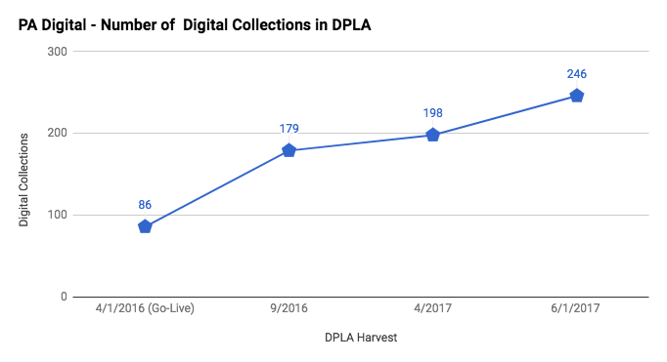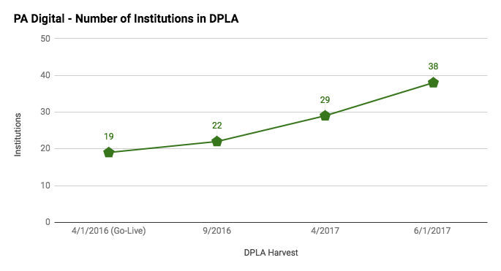](https://na01.safelinks.protection.outlook.com/?url=http%3A%2F%2Fdp.la%2Fsearch%3Fpartner%255B%255D%3DPA%2BDigital%26q%3D%252A%26utf8%3D%25E2%259C%2593&data=02%7C01%7Cdmegdad%40pa.gov%7C4c913d1b6aa74ea908e008d4bfcf013e%7C418e284101284dd59b6c47fc5a9a1bde%7C1%7C0%7C636344343180925136&sdata=JlVNaBRA0sw8i3tGVvOz7bTaej66ej2PdemmUDpCvdw%3D&reserved=0)