Board’s Role:
TRUSTEE WORKSHOPS

Community Engagement:

Governance and Effective Meetings
Michael Kumer is Principal of Boards MTO, a consulting firm helping boards attain excellence in all areas of governance. Topics for this workshop will include an overview of what great boards do, effective meetings, and the role of Boards and Directors including:
- What do great boards (and great board members) do?
- Your most effective meeting. Ever!
- What are the roles and responsibilities of the board and its individual board members?

Saturday, April 8
Coffee: 9 to 9:30 a.m. | Presentation: 9:30 a.m. to 12:30 p.m.

Tredyffrin Township Library 582 Upper Gulph Road Strafford, PA 19087
Good Leaders Build Great Relationships
Are you looking for new ways to engage your community about library issues and change the conversation community-wide? Join John Chrastka, executive director of EveryLibrary, as he discusses tools and techniques to energize, focus, and improve your relationship building efforts. Learn new approaches that resonate with the public and leaders of organizations, agencies, and stakeholders in your towns. This session will include collaborative learning that you can take back to your board colleagues to enhance your planning and community outreach.

Saturday, April 29
Coffee: 9 to 9:30 a.m. | Presentation: 9:30 a.m. to 12:30 p.m.

Free Library of Northampton Township 25 Upper Holland Road
Richboro, PA 18954

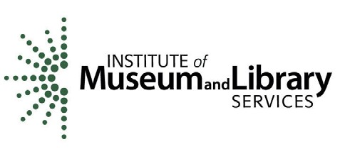
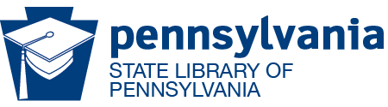

REGISTER: for either or both workshops: https://www.surveymonkey.com/r/2017trusteeworkshop
These events are made possible, in part, by a grant from the Institute of Museum and Library Sciences as administered by the Pennsylvania Department of Education through the Office of Commonwealth Libraries, and the Commonwealth of Pennsylvania, Tom Wolf, Governor.

