Livestreaming Instructors
October 4-6

http://livestream.com/hulive/ILEAD

John Brice
John Brice hails from the snowy landscape of Northwest Pennsylvania. John was educated in Erie through the parochial grade school system and eventually graduated from Gannon University with a degree in Accounting. While working at Gannon, John worked at the old Erie Public Library Main building for four years.

At Erie Brice worked as a part-time clerical clerk in just about every department except Inter Library Loan.
Upon graduating Gannon John became Director of the Ripley Free Library in Ripley New York.

In 1987 John relocated to Tampa Florida and pursued his MLIS Degree from the University of South Florida. John worked as cataloger at the University Media Center and at the same time worked at Walt Disney World as a Ticket Host. John received his MLIS degree in 1989 and immediately went to Beverly MA as Branch Manager of the Beverly Farms Library. In 1989 John came home to Erie and worked as Branch Manager for the Erie County Library System running, at different times the Edinboro, Lawrence Park, and Millcreek Mall Branches.

In 1991 John became Director of the Meadville Public Library, the largest library and System Headquarters for the Crawford County Federated Library System. John is also CEO of CCFLS. John's tenure at Meadville has been noted for his passion of integrating open source technology into all aspects of the Crawford County Libraries operations from web pages, email, to administration, to circulation. CCFLS Libraries not only use open source software but contribute code, participate in user meeting and hackathons and even write their own software. Libkey, a Kiosk patron authentication and time management system, is now is use by over 100 libraries across the world.

John's interest in video goes back to when he was a toddler and had a special fascination with the Three Stooges. John's middle school was fortunate as it had a fully functioning tv studio in which students made videos and produced a weekly tv show on school events. Over the years John has produced a number of videos for the Gannon Model United Nations (his video almost caused a mock nuclear war to develop), the Meadville Kiwanis Club and various retirement party videos. MPL is currently planning on opening a small video production studio as part of a larger electronic maker space to be opened in 2016.

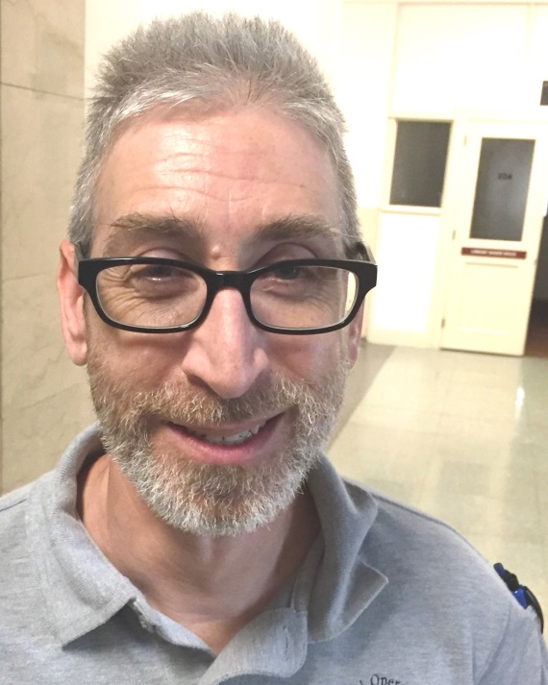

Bill Fee
Bill Fee is a library advisor at the
Office of Commonwealth Libraries.
He is in charge of IT and maker space technology.

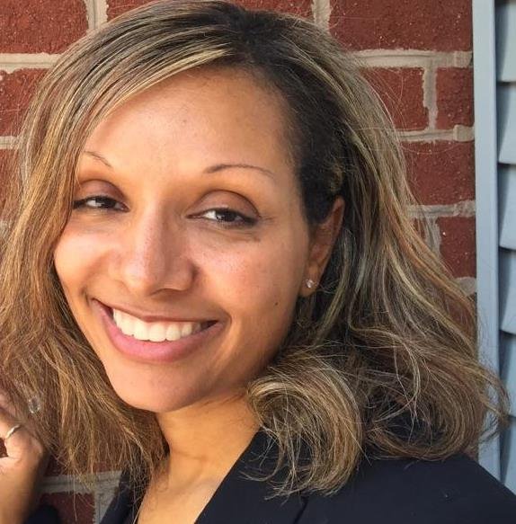
Brandi Hunter-Davenport
Brandi Hunter-Davenport has nearly 15 years of experience under her belt, which has been honed in sectors ranging from higher education to state government to the nonprofit realm. Each of these venues has provided her with extensive growth in partnership building and recruitment, grassroots development, legislative outreach, event planning, media relations, writing, training, campaign outreach and marketing, and public speaking. Hunter-Davenport is the new PA Forward Project Manager!
Prior to joining the association, Hunter-Davenport was the director of communications for the state Department of Agriculture, working on communication platforms which focused on areas such as the restoration of the Chesapeake Bay, the potential of the High Path Avian Influenza Virus and racing reform in the commonwealth. She has also served as the director of public affairs and education with the Pennsylvania Association of Conservation Districts and handled press, marketing and communications with the state Departments of Environmental Protection and Health as well as a member of Governor Rendell's communication team. Hunter-Davenport has spent some time as an adjunct professor in the Communications Department at Messiah College. She currently sits on the American Lung Association's Southcentral Region Leadership Board, is a member of the Pa Public Relations Society and is very active with her sorority, Delta Sigma Theta Sorority, Inc. Brandi resides in Harrisburg with her husband and two children.

Jessica Miller
Miller currently works as a System Coordinator for the Washington County Library System where she works with libraries to provide better service throughout the county. Previously she had worked at Flenniken Public Library for 11 years where she worked her way from a position as a library clerk to director, along the way doing everything, including technology coordinator. Miller has also been a computer consultant and is a PALS graduate.

