2016 ILEAD USA Livestreaming July 12-14
Instructors

Cindy Murdock Ames

Cindy Murdock Ames is IT Director for Meadville Public Library and the Crawford County Federated Library System, is a specialist in implementing cost effective open source solutions in public libraries with small budgets.

Her successful projects include implementing the Koha ILS in all CCFLS libraries, managing public & staff Linux desktops with puppet, installing Linux-based thin clients for public computing & public catalog computers using the Linux Terminal Server Project, and pfsense routers utilizing OpenVPN to securely connect all CCFLS libraries.

Carolyn Blatchley
Carolyn Blatchley is the Training Services Coordinator at the Cumberland County Library System in Carlisle, PA.

1n 1997, she received her MLIS from the University of Pittsburgh, where she first engaged in teaching technology to adult learners through web site design and reference database training. The emphasis of her current work is strengthening staff information technology and public services skills, which she implements through a system-wide staff training program.

In her 13 years with Cumberland County Library System, and as a volunteer with the Pennsylvania Library Association, Carolyn has overseen four complete website redesign projects. She is not a coder, but she plays one in a pinch.

John Brice
John Brice hails from the snowy landscape of Northwest Pennsylvania. John was educated in Erie through the parochial grade school system and eventually graduated from Gannon University with a degree in Accounting. While working at Gannon, John worked at the old Erie Public Library Main building for four years.

At Erie Brice worked as a part-time clerical clerk in just about every department except Inter Library Loan.
Upon graduating Gannon John became Director of the Ripley Free Library in Ripley New York.

In 1987 John relocated to Tampa Florida and pursued his MLIS Degree from the University of South Florida. John worked as cataloger at the University Media Center and at the same time worked at Walt Disney World as a Ticket Host. John received his MLIS degree in 1989 and immediately went to Beverly MA as Branch Manager of the Beverly Farms Library. In 1989 John came home to Erie and worked as Branch Manager for the Erie County Library System running, at different times the Edinboro, Lawrence Park, and Millcreek Mall Branches.

In 1991 John became Director of the Meadville Public Library, the largest library and System Headquarters for the Crawford County Federated Library System. John is also CEO of CCFLS. John's tenure at Meadville has been noted for his passion of integrating open source technology into all aspects of the Crawford County Libraries operations from web pages, email, to administration, to circulation. CCFLS Libraries not only use open source software but contribute code, participate in user meeting and hackathons and even write their own software. Libkey, a Kiosk patron authentication and time management system, is now is use by over 100 libraries across the world.

John's interest in video goes back to when he was a toddler and had a special fascination with the Three Stooges. John's middle school was fortunate as it had a fully functioning tv studio in which students made videos and produced a weekly tv show on school events. Over the years John has produced a number of videos for the Gannon Model United Nations (his video almost caused a mock nuclear war to develop), the Meadville Kiwanis Club and various retirement party videos. MPL is currently planning on opening a small video production studio as part of a larger electronic maker space to be opened in 2016.

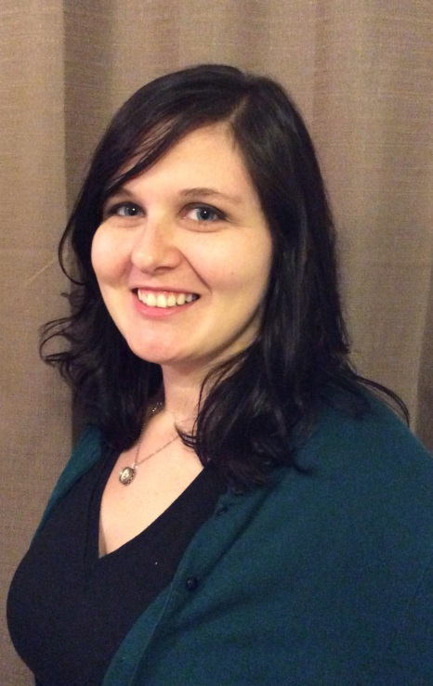

Dana Farabaugh
Dana Farabaugh is an Information and Community Education Librarian at the Altoona Area Public Library. She provides reference services and technology assistance to patrons of all ages in addition to teaching various information literacy classes for adults.
Dana also helps manage the library's maker space, which lead to an interest in how libraries can use maker technology to teach STEM skills to people of all ages. She realized her job is awesome when her father helped her build and program a LEGO Mindstorm robot and he said, "I can't believe you get paid to do this."

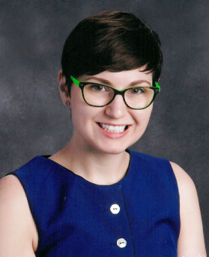
Sara Frey
Sara Frey is the Instructional Media Specialist and Technology Integration Coach for Plymouth Whitemarsh High School in Plymouth Meeting, Pennsylvania. In addition to managing the school's library program, Sara hosts events in the library's makerspace and provides support for teachers concerning best practices for using technology in instruction.

She has been a guest speaker at International Society for Technology in Education (ISTE) the American Association of School Librarians (AASL) events, as well as other state library and technology functions.

Sara received the Pennsylvania Library Association (PaLA) 2015 Best Practices Award for high schools. In June, Sara was awarded grant funding from the American Association of School Librarians (AASL) for special programming for teens with intellectual disabilities, as well as funding from the Young Adult Library Services Association (YALSA) for Teen Read Week activities for English Language Learners.

Sara earned her Master's of Library and Information Sciences from the University of Kentucky.

Katie Goodling
Katie Goodling is the Social Media Manager at WebpageFX, a Harrisburg-based internet marketing agency. She is passionate about helping businesses and organizations utilize social media and other digital technologies to reach relevant audiences and to drive results.

Michael Hayward
Michael started working at Schlow Centre Region Library as a volunteer, where he was eventually hired to a part-time position that he began automating using macros. When the opportunity arose for a full-time position in Schlow’s IT Services department, he applied and accepted based on his co-worker’s encouragement.
In his current position, Michael strives to create new and interesting technology to meet the needs of his co-workers and the patrons of Schlow Library. Some notable projects include “My Library Card", an Android/iPhone App that holds all the Schlow library cards for a family, or the redesign of Schlow’s notices to improve communication and create opportunities for promotion.
Cody Kinneer

Cody Kineer is a senior at Allegheny College in Meadville PA and works for the Meadville Public Library's IT department. Cody began working for the library his freshman year at the fiction circulation desk and switched to IT during his sophomore year. Cody's intended major is computer science and he is a member of the Association for Computing Machinery.

Nathaniel Rasmussen
Nathaniel has been working for Schlow Centre Region Library for most of his adult life; he started as a page when he was 15 and is now the Head of IT Services. His interest in technology has always been through the lens of how to best provide public access to information. That's probably why he's so interested in the freedom that Open Source software provides. Within the past year, he's worked hard to redefine Schlow's online presence into a digital branch that fulfills his vision of "We are, where you are."

His civic interests include serving on the C-NET (Centre County edu/gov access channels) board of directors, helping regional non-profits find sustainable technology, and buying whatever he can fresh and local. Personally, he enjoys playing electronic/folk music, collecting vintage vinyl (especially jazz), and spending time with his wife and son.

