**LibPAS Access for District Library Consultants**

1. Go to <http://pa.countingopinions.com>
2. Click Login.

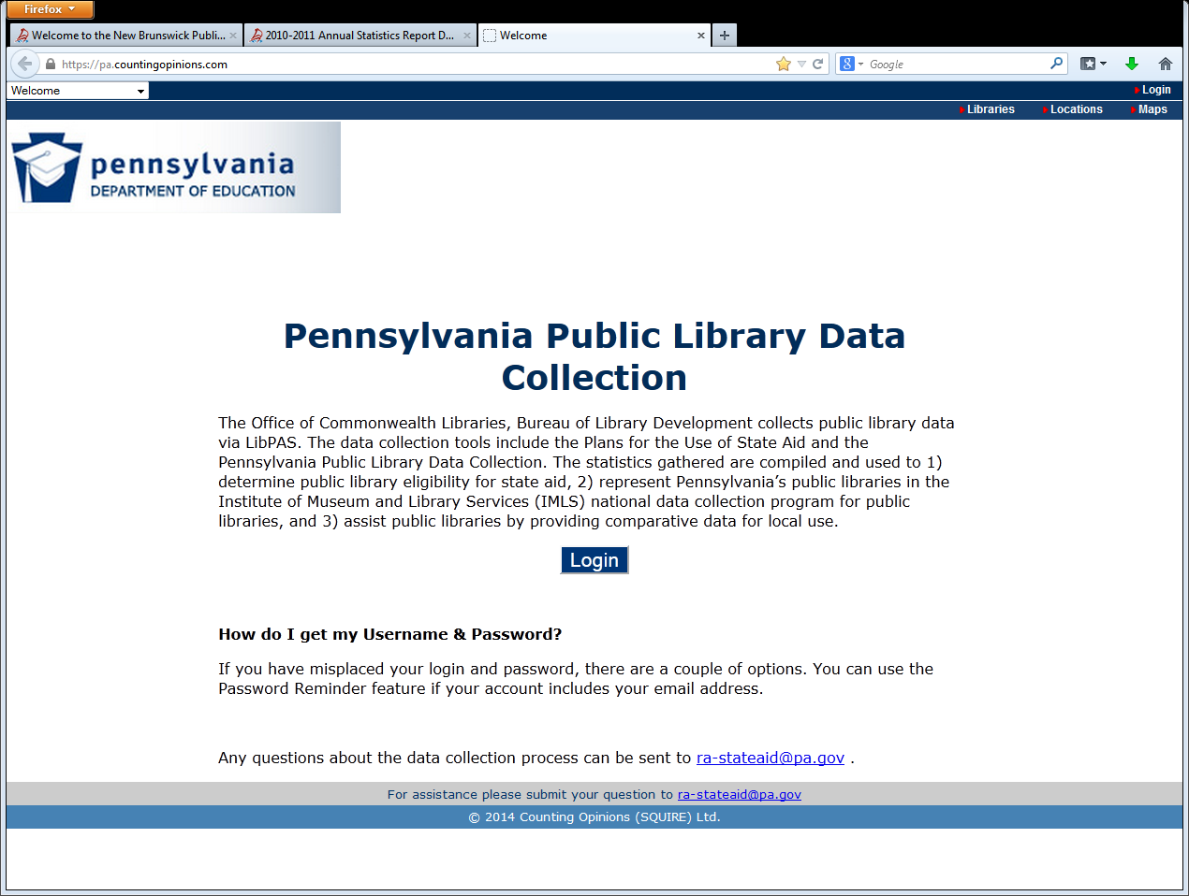

1. Enter your District Username and Password. If you misplace the username and password, please contact the Office of Commonwealth Libraries at [ra-stateaid@pa.gov](mailto:ra-stateaid@pa.gov).

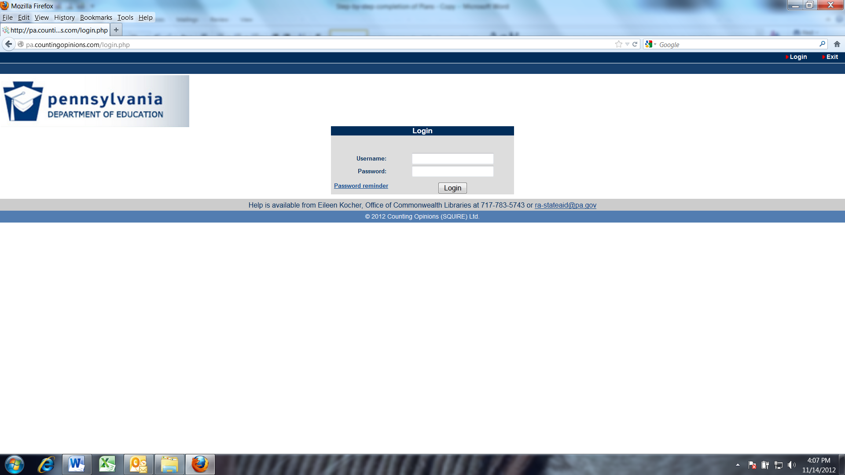

1. After login, you will be taken to the “Welcome” screen. Select “Begin”.

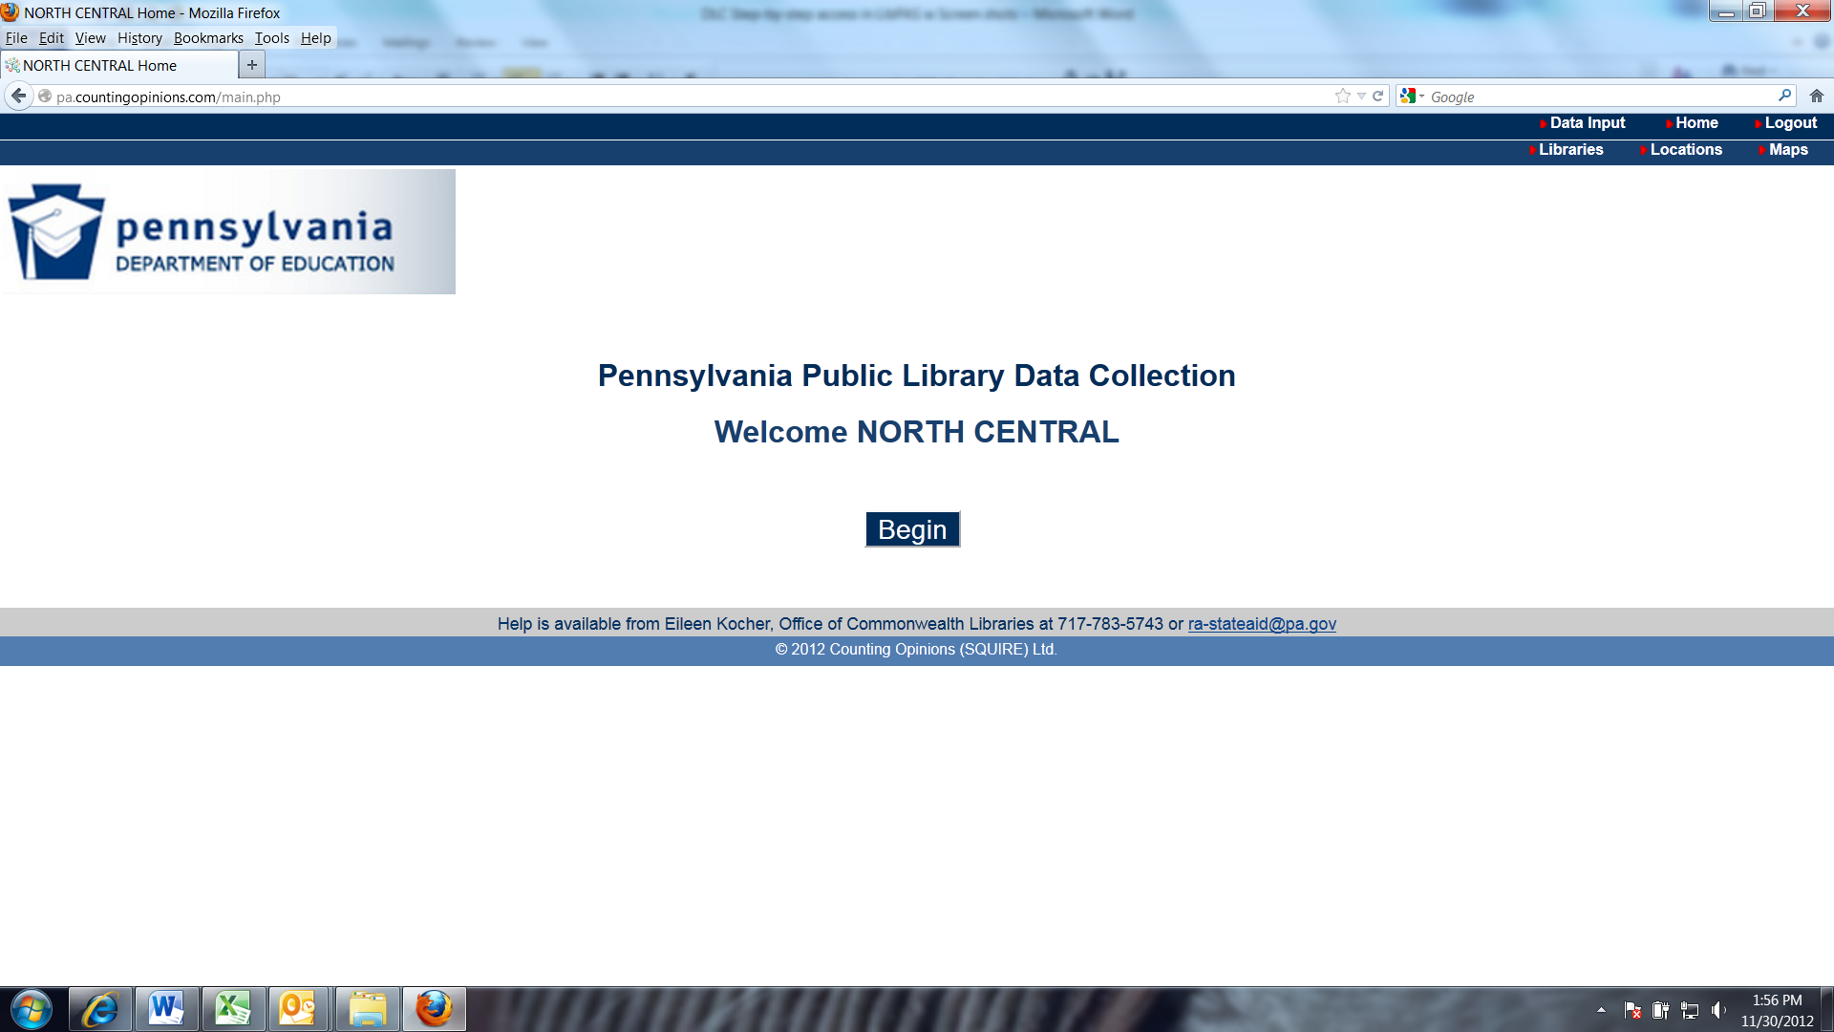

1. The Data Input screen will appear. Drop down the Collection Selection menu and select “Pennsylvania Public Library Data Collection.” Be sure the reporting period is set to “2014”.

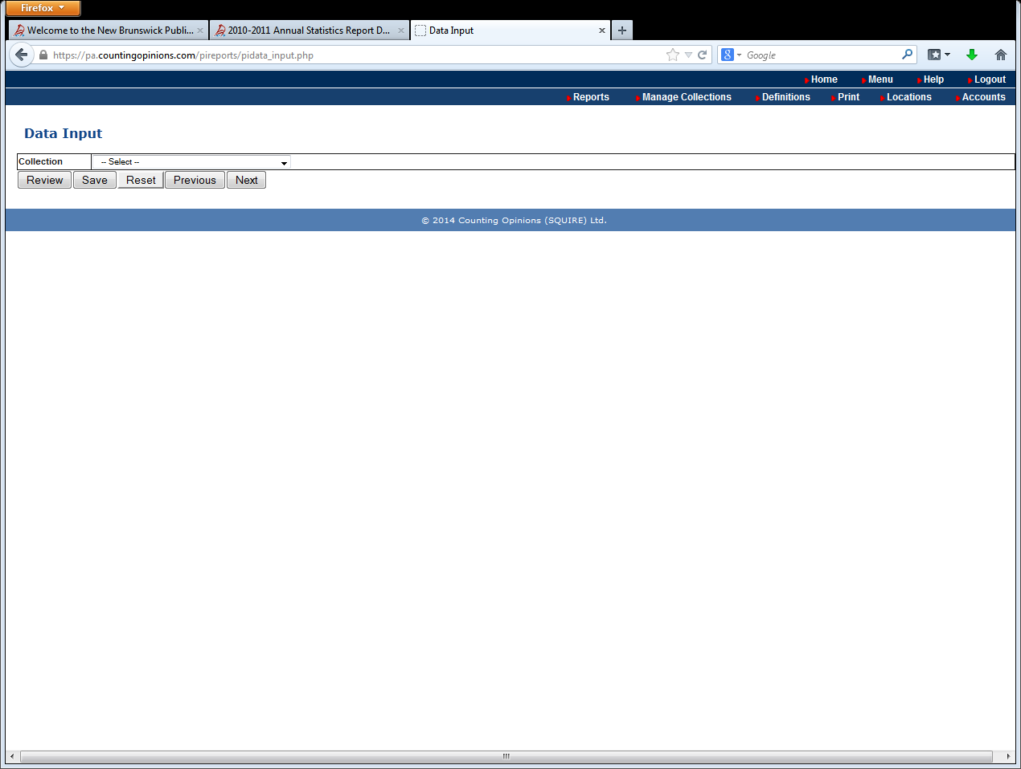

1. At the top of the Data Input screen, click the dropdown arrow next to Library to display all the libraries in the district. Click on the library name to load the data for that library.

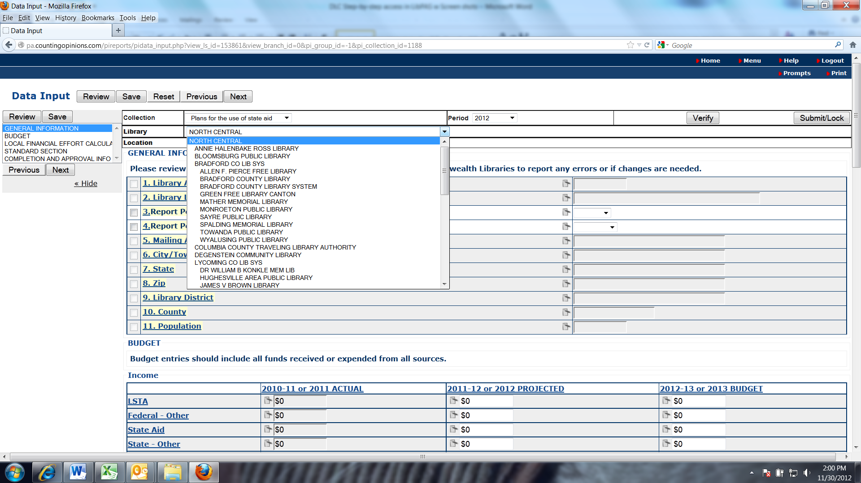

1. Review the data for completeness and any errors. Use the “District Library Consultants Review Checklist” as a guide for the review. Work with the reporting libraries to make corrections or clarify any issues.
2. Once the form is locked by the library, the district consultant will see the following options where the Submit/Lock button is on the Data Input screen:

Images intégrées 1

1. Consultants will have the option to Unlock the form to make changes or for the library to make the changes. Click Approve to signal to the state the data has been reviewed and all changes have been made.  Once the data is Approved, District Consultants can no longer Unlock or modify any data. If a change is required, only the state library can Unlock the data to make changes or enable the submitting Location to modify its data.